Answer your friend’s email
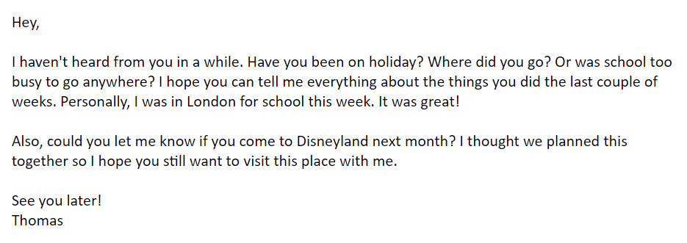
Let Thomas know how you are doing and if you will join him in Disneyland. Write a correct answer to this mail. Make a text of 50-75 words.
________________________________________________________________________________________________________________________________________________________________________________________________________________________________________________________________________________________________________________________________________________________________________________________________________________________________________________________________________________________________________________________________________________________________________________________________________________________________________________________________________________________________________________________________________________________________________________________________________________________________________________________________________________________________________________________________________________________________________________________________________________________________________________________________________________________________________________________________________________________________________________________________________________________________________________________________________________________________________________________________________________________________________________________________________________________________________________________________________________________________________________________________________________________________________________________________________________________________________________________________________________________________________________________________________________________________________________________________________________________________________________________________________________________________________________________________________________________________________________________________________________________________________________________________________________________________________________________________________________________________________________________________________________________________________________________________________________________________________________________________________________________________________________________________________________________________________________________________________________________________________________________________________________________________________________________________________________________________________________________________________________________________________________________________________________________________________________________________________________________________________________________________________________________________________________________________________________________________________________________________________________________________________________________________________________________________________________________________________________________________________________________________________________________________________________________________________________________________________________________________________________________________________________________________________________________________________________________________________________________________________________________________________________________________________________________________________________________________________________________________________________________________________________________________________________________________________________________________________________________________________________________________________________________________________________________________________________________________________________________________________________________________________________________________________________________________________________________________________________________________________________________________________________________________________________________________________________________________________________________________________________________________________________________________________________________________________________________________________________________________________________________________________________________________________________________________________________________________________________________________________________________________________________________________________________________________________________

