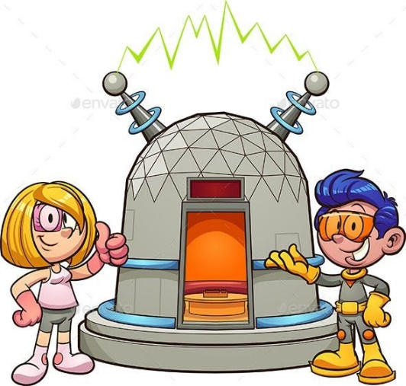Writing a letter to yourself

If someone would invent a time machine, there would be a lot of options to contact the younger version of yourself. We are going to write a letter to yourself. We will send it to you when you are 7 years old. You will send this letter to the past, but you still need to write it. What do you want to tell your younger version? Tell him/her about the last couple of years. What changed in your life? What are your hobbies? Who are your friends? How is school going?

Write everything you can think of. Make a text of 100+ words.

________________________________________________________________________________________________________________________________________________________________________________________________________________________________________________________________________________________________________________________________________________________________________________________________________________________________________________________________________________________________________________________________________________________________________________________________________________________________________________________________________________________________________________________________________________________________________________________________________________________________________________________________________________________________________________________________________________________________________________________________________________________________________________________________________________________________________________________________________________________________________________________________________________________________________________________________________________________________________________________________________________________________________________________________________________________________________________________________________________________________________________________________________________________________________________________________________________________________________________________________________________________________________________________________________________________________________________________________________________________________________________________________________________________________________________________________________________________________________________________________________________________________________________________________________________________________________________________________________________________________________________________________________________________________________________________________________________________________________________________________________________________________________________________________________________________________________________________________________________________________________________________________________________________________________________________________________________________________________________________________________________________________________________________________________________________________________________________________________________________________________________________________________________________________________________________________________________________________________________________________________________________________________________________________________________________________________________________________________________________________________________________________________________________________________________________________________________________________________________________________________________________________________________________________________________________________________________________________________________________________________________________________________________________________________________________________________________________________________________________________________________________________________________________________________________________________________________________________________________________________________________________________________________________________________________________________________________________________________________________________________________________________________________________________________________________________________________________________________________________________________________________________________________________________________________________________________________________________________________________________________________________________________________________________________________________________________________________________________________________________________________________________________________________________________________________________________________________________________________________________________________________________________________________________________________________________________________